Name: Harish Arjun

Emp Id: 289241

Step 1: Create a github repository with a readme file.

Step 2: Create a portifolio using HTML,CSS&JS.

Step 3: Initialize Git in that folder.

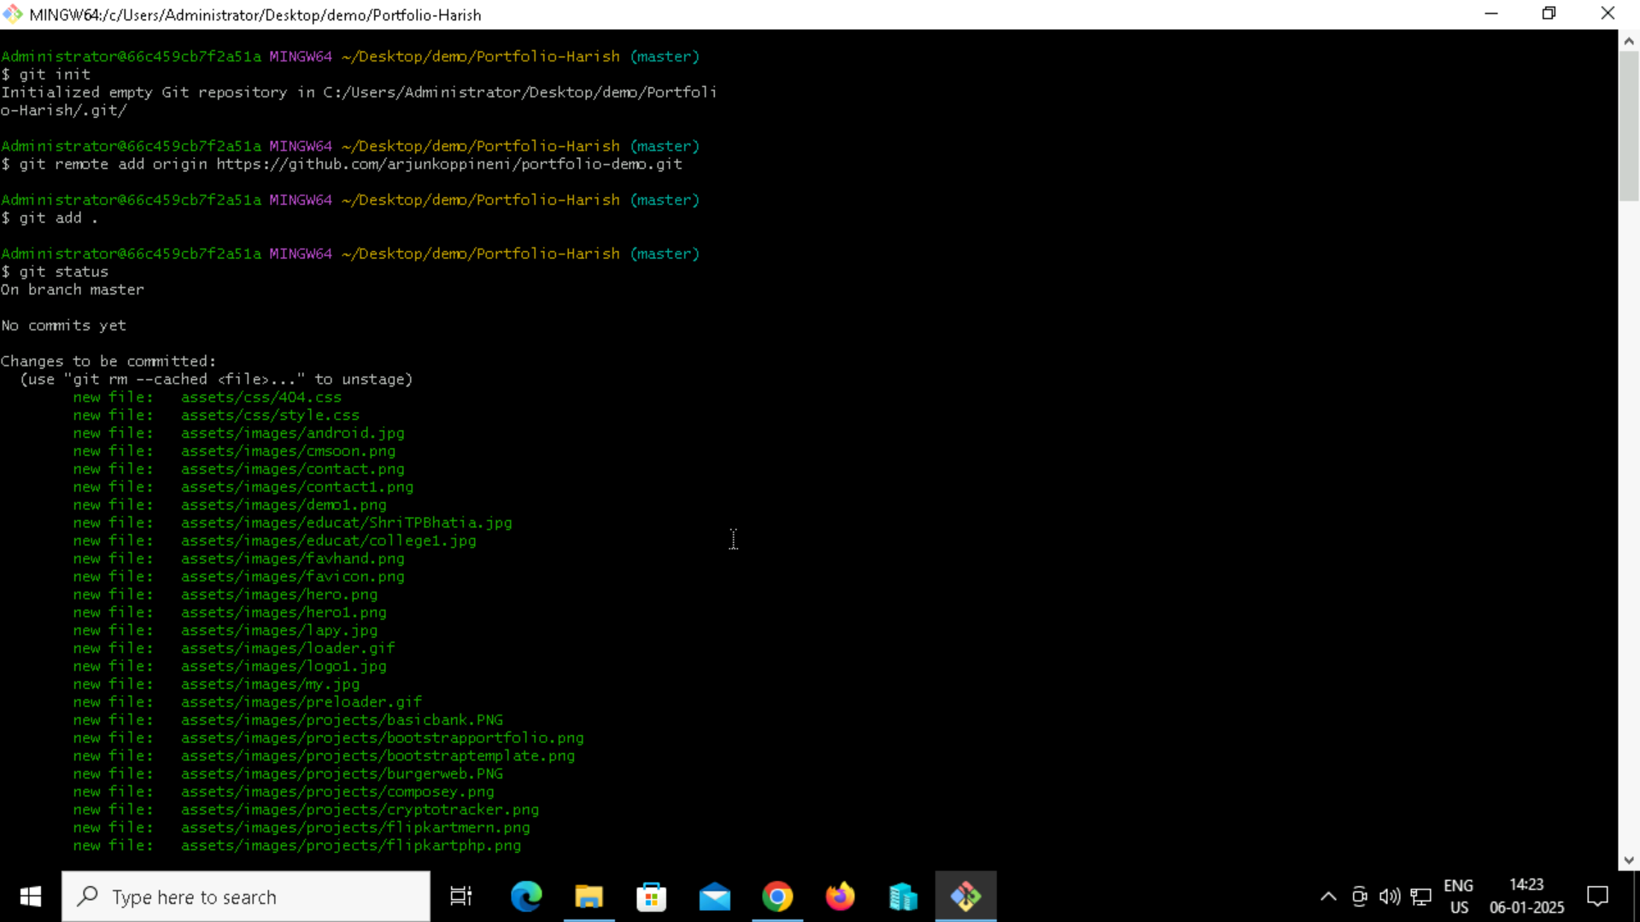

Step 4: By Using Git commands push the project to github.

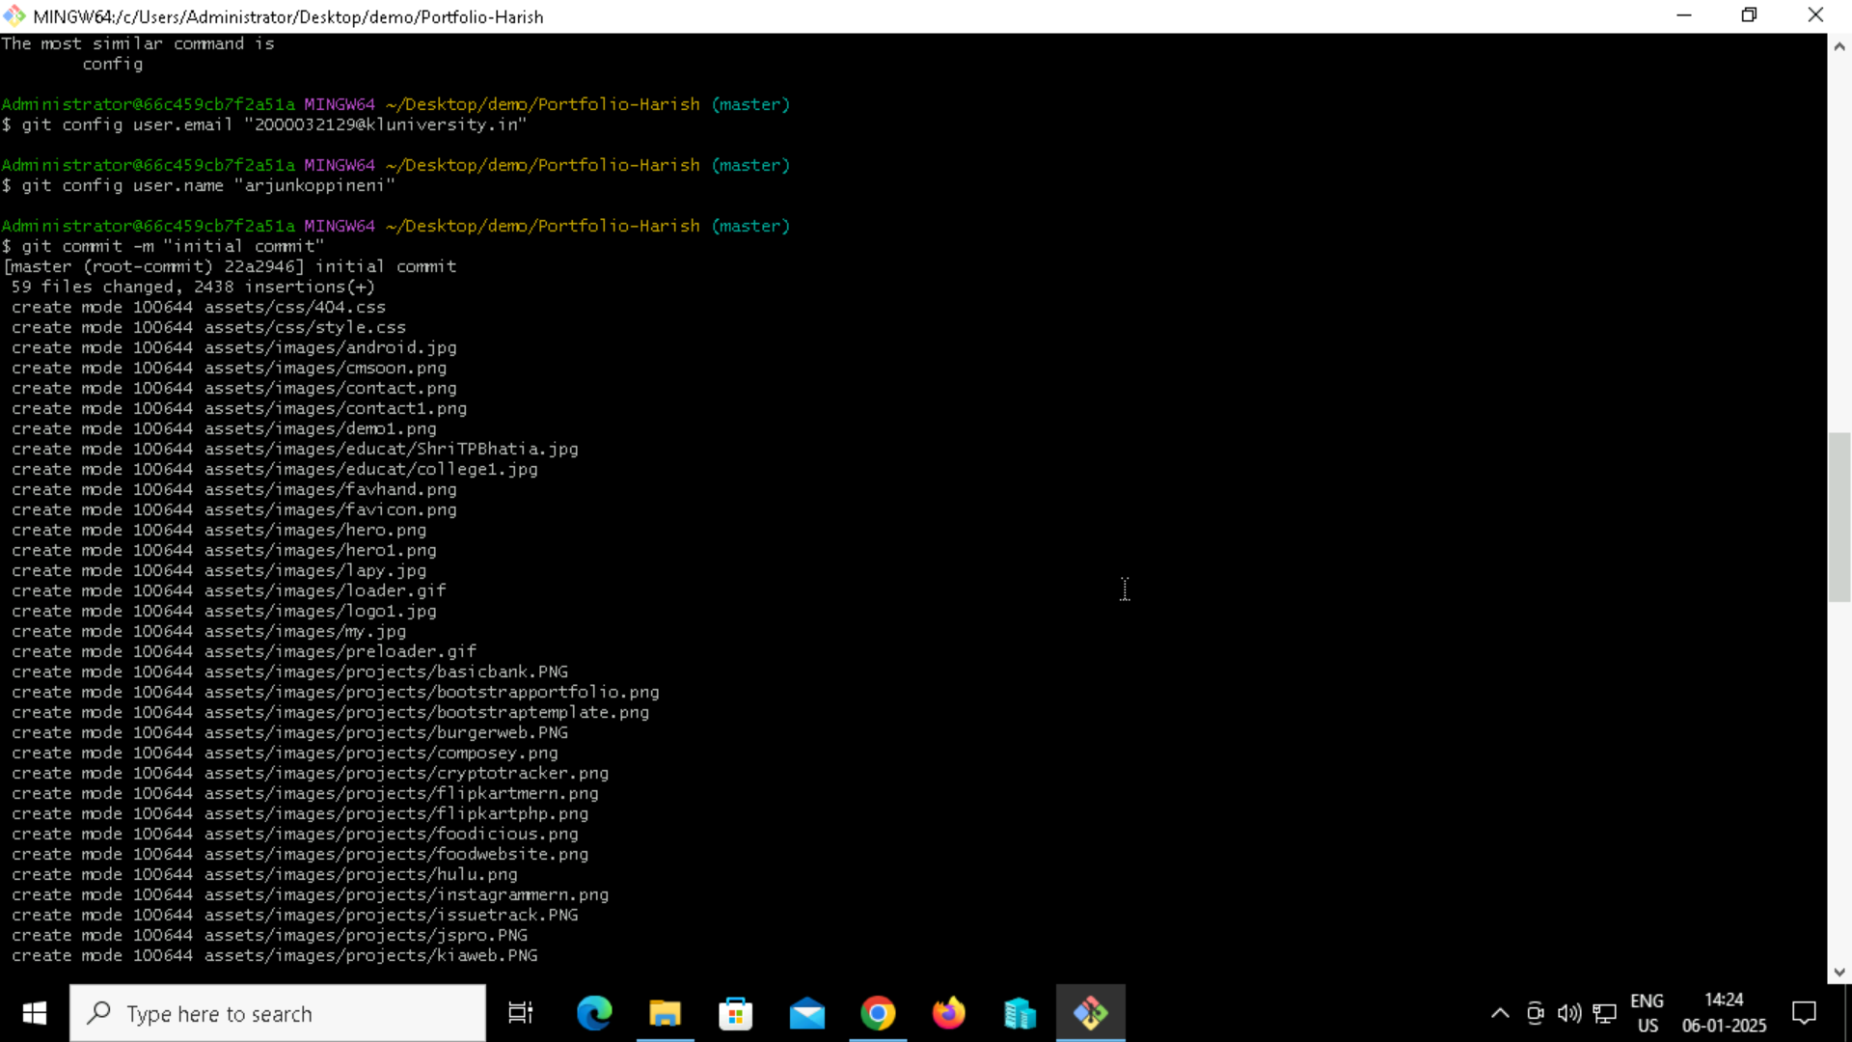

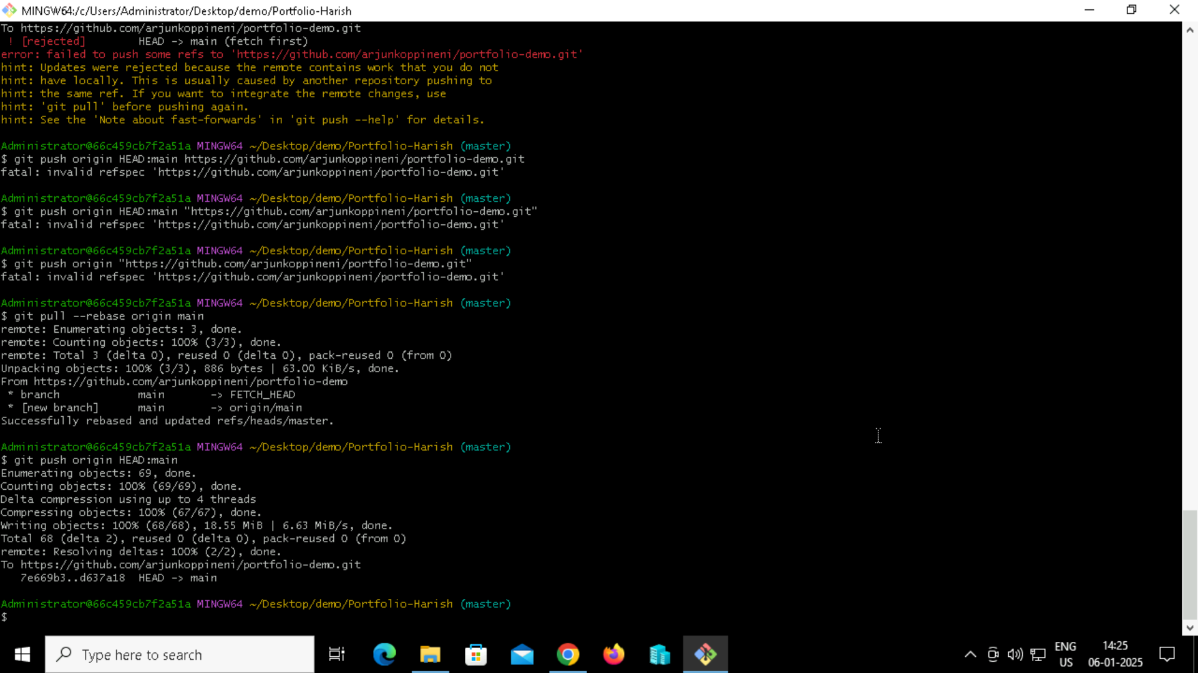

Step 5:After Pushing the files to github, Go to pages option and select branch that containing files.

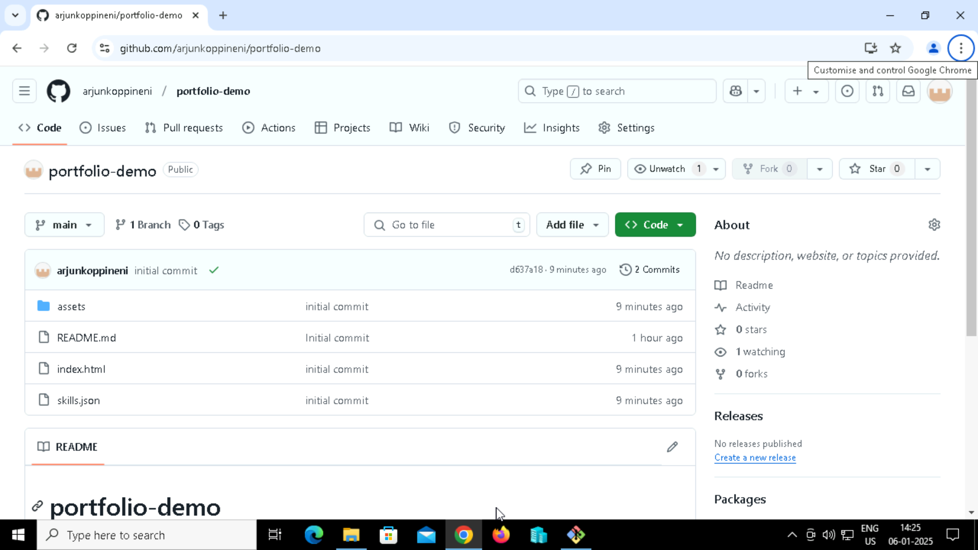

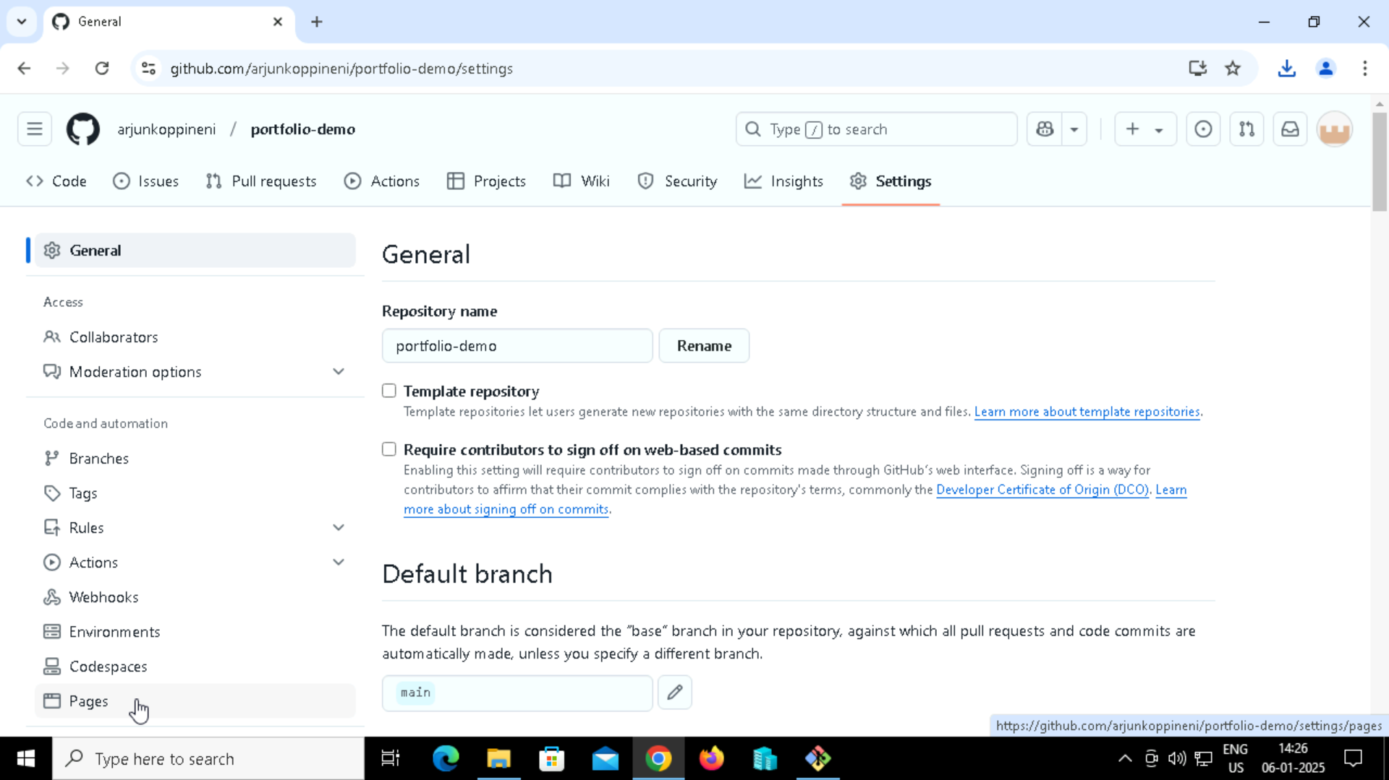

Step 6: After enabling, a link will be popped up that will be the link of the hosted portifolio.

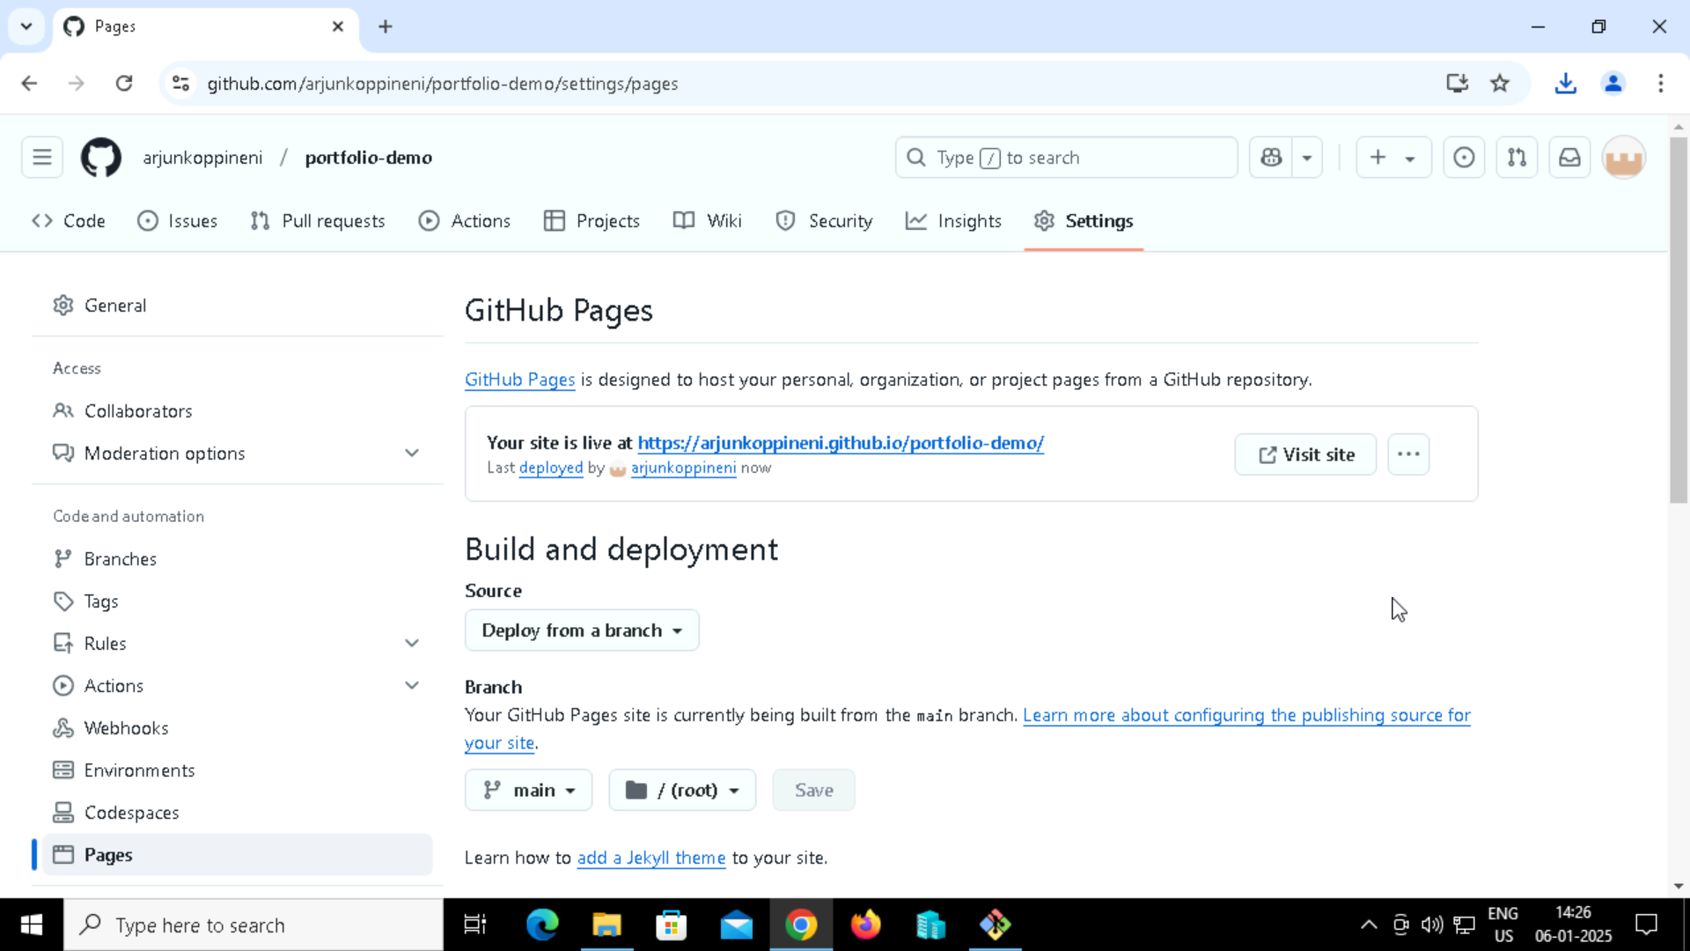

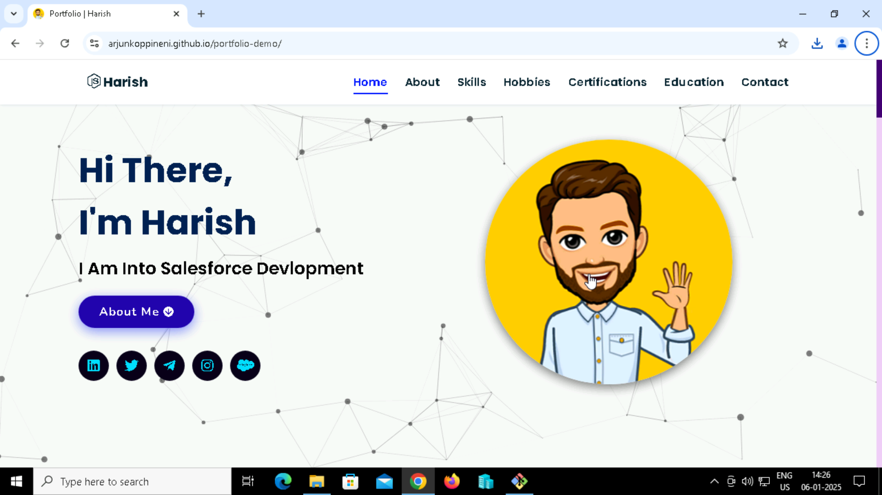

INDEX.HTML

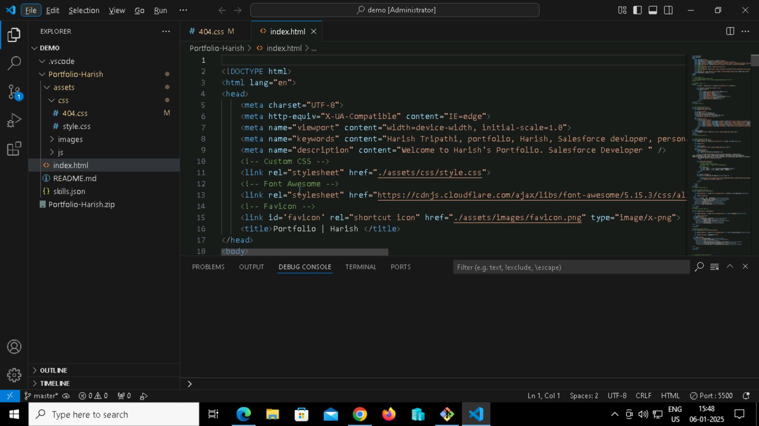

<!DOCTYPE html>

<html lang="en">

<head>

    <meta charset="UTF-8">

    <meta http-equiv="X-UA-Compatible" content="IE=edge">

    <meta name="viewport" content="width=device-width, initial-scale=1.0">

    <meta name="keywords" content="Harish Tripathi, portfolio, Harish, Salesforce devloper, personal portfolio lifecodes, portfolio design, portfolio website, personal portfolio" />

    <meta name="description" content="Welcome to Harish's Portfolio. Salesforce Developer " />

    <!-- Custom CSS -->

    <link rel="stylesheet" href="./assets/css/style.css">

    <!-- Font Awesome -->

    <link rel="stylesheet" href="https://cdnjs.cloudflare.com/ajax/libs/font-awesome/5.15.3/css/all.min.css" integrity="sha512-iBBXm8fW90+nuLcSKlbmrPcLa0OT92xO1BIsZ+ywDWZCvqsWgccV3gFoRBv0z+8dLJgyAHIhR35VZc2oM/gI1w==" crossorigin="anonymous" referrerpolicy="no-referrer" />

    <!-- Favicon -->

    <link id='favicon' rel="shortcut icon" href="./assets/images/favicon.png" type="image/x-png">

    <title>Portfolio | Harish </title>

</head>

<body>

<!-- pre loader -->

<!-- <div class="loader-container">

  <img draggable="false" src="./assets/images/preloader.gif" alt="">

</div> -->

<!-- navbar starts -->

<header>

        <a href="/" class="logo"><i class="fab fa-node-js"></i> Harish</a>

        <div id="menu" class="fas fa-bars"></div>

        <nav class="navbar">

            <ul>

            <li><a class="active" href="#home">Home</a></li>

            <li><a href="#about">About</a></li>

            <li><a href="#skills">Skills</a></li>

            <li><a href="#Hobbies">Hobbies</a></li>

            <li><a href="#certifications">Certifications</a></li>

            <li><a href="#education">Education</a></li>

            <li><a href="#contact">Contact</a></li>

            </ul>

        </nav>

</header>

<!-- navbar ends -->

<!-- hero section starts -->

<section class="home" id="home">

    <div id="particles-js"></div>

    <div class="content">

    <h2>Hi There,<br/> I'm Harish</h2>

    <p>I am Into Salesforce Devlopment</p>

    <a href="#about" class="btn"><span>About Me</span>

      <i class="fas fa-arrow-circle-down"></i>

    </a>

    <div class="socials">

        <ul class="social-icons">

          <li><a class="linkedin" aria-label="LinkedIn" href="https://www.linkedin.com/in/Harish-tripathi-13624b21a/" target="_blank"><i class="fab fa-linkedin"></i></a></li>

          <li><a class="twitter" aria-label="Twitter" href="https://twitter.com/HarishTr34" target="_blank"><i class="fab fa-twitter"></i></a></li>

          <li><a class="telegram" aria-label="Telegram" href="https://web.telegram.org/a/" target="_blank"><i class="fab fa-telegram-plane"></i></a></li>

          <li><a class="instagram" aria-label="Instagram" href="https://www.instagram.com/prashaant_tripathii/"><i class="fab fa-instagram" target="_blank"></i></a></li>

          <li><a class="salesforce" aria-label="Salesforce" href="https://www.salesforce.com/trailblazer/Harisht99" target="_blank"><i class="fab fa-salesforce"></i></a></li>

        </ul>

      </div>

    </div>

<div class="image">

    <img draggable="false" class="tilt" src="./assets/images/hero.png" alt="">

</div>

</section>

<!-- hero section ends -->

<!-- about section starts -->

<section class="about" id="about">

    <h2 class="heading"><i class="fas fa-user-alt"></i> About <span>Me</span></h2>

    <div class="row">

    <div class="image">

        <img class="tilt" src="./assets/images/demo1.png" alt="">

    </div>

    <div class="content">

        <h3>I'm Harish</h3>

        <span class="tag">Salesforce Developer</span>

        <p>I am a Salesforce developer with entry-level experience, specializing in

 Agile methodology, Java, Apex, Lightning Web Component ,VisualForce and API Integration.

 Adapt at developing CRM solutions for client businesses and identifying opportunities to improve the user experience.

          Working for myself to improve my skills.

           </p>

        <div class="box-container">

            <!-- <div class="box">

              <p><span> age: </span> 20</p>

              <p><span> phone : </span> +91 9769542615</p>

            </div> -->

            <div class="box">

              <p><span> email : </span> Harishtripathi0304@gmail.com</p>

              <p><span> place : </span> Mumbai, India - 400101</p>

            </div>

        </div>

        <div class="resumebtn">

        <p><span><h2><b>Check Out My Resume</b></h2></span></p>

            <a href="https://drive.google.com/file/d/1YpGQptsg5cw61HTvV__ZtNn-iHmfIjXn/view?usp=drive_link" target="_blank" class="btn"><span>Resume</span>

                <i class="fas fa-chevron-right"></i>

            </a>

        </div>

    </div>

    </div>

</section>

<!-- about section ends -->

<!-- skills section starts -->

<section class="skills" id="skills">

    <h2 class="heading"><i class="fas fa-laptop-code"></i> Skills & <span>Abilities</span></h2>

    <div class="container">

  <ul>

  <h1><li><i><b>HTML , CSS , JAVASCRIPT </li></i></b></h1><br>

    <h1><li><i><b>Lightning Web Component</li></i></b></h1><br>

      <h1><li><i><b>APEX Programming</li></i></b></h1><br>

    <h1><li><i><b>VisualForce</li></i></b></h1><br>

    <h1><li><i><b>Salesforce.com</li></i></b></h1><br>

    <h1><li><i><b>API Integrations</li></i></b></h1><br>

</ul>

      </div>

</section>

<!-- skills section ends -->

<section class="skills" id="Hobbies">

    <h2 class="heading"><i class="fas fa-laptop-code"></i> <span><u>Hobbies</span></u></h2>

    <div class="container">

  <ul type="circle">

  <h1><li><i><b>Sometimes Travelling </li></i></b></h1><br>

    <h1><li><i><b> Reading Blogs </li></i></b></h1><br>

      <h1><li><i><b>Video & Photo Editing</li></i></b></h1><br>

      <h1><li><i><b>Photography</li></i></b></h1><br>

      <h1><li><i><b>Volunteering</li></i></b></h1><br>

</ul>

      </div>

</section>

<!--Hobbies section ends-->

<section class="skills" id="Certifications">

    <h2 class="heading"><i class="fas fa-laptop-code"></i> <span><u>Certifications</span></u></h2>

    <div class="container" draggable="false">

  <ul type="square">

  <h1><li><i><b> BOT Devlopment </li></i></b></h1><br>

    <h1><li><i><b> Arduino Programming </li></i></b></h1><br>

      <h1><li><i><b> C# </li></i></b></h1><br>

      <h1><li><i><b>Data Warehousing and Business Intelligence</li></i></b></h1><br>

      <h1><li><i><b>Instagram Marketing Fundamentals</li></i></b></h1><br>

        <h1><li><i><b>Introduction To Programming Using Python</li></i></b></h1><br>

</ul>

      </div>

</section>

<!-- education section starts -->

<section class="education" id="education">

  <h1 class="heading"><i class="fas fa-graduation-cap"></i> My <span>Education</span></h1>

    <p class="qoute">Education is not the learning of facts, but the training of the mind to think.</p>

    <div class="box-container">

    <div class="box">

        <div class="image">

        <img draggable="false" src="./assets/images/educat/college1.jpg" alt="">

        </div>

        <div class="content">

        <h3>Bachelor of Science in Information Technology</h3>

        <p>KES SHROFF COLLEGE | KESSC</p>

        <h4>2020-2023 | Graduated</h4>

        </div>

    </div>

    <div class="box">

      <div class="image">

      <img draggable="false" src="./assets/images/educat/ShriTPBhatia.jpg" alt="">

      </div>

      <div class="content">

      <h3>HSC Science </h3>

      <p>Shri  T.P. Bhatia Jr. Collge | HSC</p>

      <h4>2018-2020 | Completed</h4>

      </div>

    </div>

</div>

</section>

<!-- education section ends -->

<!-- contact section starts -->

<section class="contact" id="contact">

  <h2 class="heading"><i class="fas fa-headset"></i> Get in <span>Touch</span></h2>

  <div class="container">

    <div class="content">

      <div class="image-box">

        <img draggable="false" src="./assets/images/contact1.png" alt="">

      </div>

    <form id="contact-form">

      <div class="form-group">

        <div class="field">

          <input type="text" name="name" placeholder="Name" required>

          <i class='fas fa-user'></i>

        </div>

        <div class="field">

          <input type="text" name="email" placeholder="Email" required>

          <i class='fas fa-envelope'></i>

        </div>

        <div class="field">

          <input type="text" name="phone" placeholder="Phone">

          <i class='fas fa-phone-alt'></i>

        </div>

        <div class="message">

        <textarea placeholder="Message" name="message" required></textarea>

        <i class="fas fa-comment-dots"></i>

        </div>

        </div>

      <div class="button-area">

        <button type="submit">

          Submit <i class="fa fa-paper-plane"></i></button>

      </div>

    </form>

  </div>

  </div>

</section>

<!-- contact section ends -->

<!-- footer section starts -->

<section class="footer">

  <div class="box-container">

      <div class="box">

          <h3>Harish's Portfolio</h3>

          <p>Thank you for visiting my personal portfolio website. Connect with me over socials. <br/> <br/> Keep Rising 🚀. Connect with me over live chat!</p>

      </div>

      <div class="box">

          <h3>Quick Links</h3>

          <a href="#home"><i class="fas fa-chevron-circle-right"></i> home</a>

          <a href="#about"><i class="fas fa-chevron-circle-right"></i> about</a>

          <a href="#skills"><i class="fas fa-chevron-circle-right"></i> skills</a>

          <a href="#Hobbies"><i class="fas fa-chevron-circle-right"></i> Hobbies</a>

          <a href="#education"><i class="fas fa-chevron-circle-right"></i> education</a>

      </div>

      <div class="box">

          <h3>contact info</h3>

          <p> <i class="fas fa-phone"></i>+91 9769542615</p>

          <p> <i class="fas fa-envelope"></i>Harishtripathi0304@gmail.com</p>

          <p> <i class="fas fa-map-marked-alt"></i>Mumbai, India-400101</p>

          <div class="share">

              <a href="https://www.linkedin.com/in/Harish-tripathi-13624b21a/" class="fab fa-linkedin" aria-label="LinkedIn" target="_blank"></a>

              <a href="mailto:Harishtripathi0304@gmail.com" class="fas fa-envelope" aria-label="Mail" target="_blank"></a>

              <a href="https://twitter.com/HarishTr34" class="fab fa-twitter" aria-label="Twitter" target="_blank"></a>

              <a href="https://web.telegram.org/a/" class="fab fa-telegram-plane" aria-label="Telegram" target="_blank"></a>

          </div>

      </div>

  </div>

  <h1 class="credit">Designed with <i class="fa fa-heart pulse"></i> by <a href="https://www.linkedin.com/in/Harish-tripathi-13624b21a/"> Harish Tripathi</a></h1>

</section>

<!-- footer section ends -->

<!-- scroll top btn -->

<a href="#home" aria-label="ScrollTop" class="fas fa-angle-up" id="scroll-top"></a>

<!-- scroll back to top -->

<!-- ==== ALL MAJOR JAVASCRIPT CDNS STARTS ==== -->

<!-- jquery cdn -->

<script src="https://cdnjs.cloudflare.com/ajax/libs/jquery/3.6.0/jquery.min.js" integrity="sha512-894YE6QWD5I59HgZOGReFYm4dnWc1Qt5NtvYSaNcOP+u1T9qYdvdihz0PPSiiqn/+/3e7Jo4EaG7TubfWGUrMQ==" crossorigin="anonymous" referrerpolicy="no-referrer"></script>

<!-- typed.js cdn -->

<script src="https://cdnjs.cloudflare.com/ajax/libs/typed.js/2.0.5/typed.min.js" integrity="sha512-1KbKusm/hAtkX5FScVR5G36wodIMnVd/aP04af06iyQTkD17szAMGNmxfNH+tEuFp3Og/P5G32L1qEC47CZbUQ==" crossorigin="anonymous" referrerpolicy="no-referrer"></script>

<!-- particle.js links -->

<script src="./assets/js/particles.min.js"></script>

<script src="./assets/js/app.js"></script>

<!-- vanilla tilt.js links -->

<script src="https://cdnjs.cloudflare.com/ajax/libs/vanilla-tilt/1.7.0/vanilla-tilt.min.js" integrity="sha512-SttpKhJqONuBVxbRcuH0wezjuX+BoFoli0yPsnrAADcHsQMW8rkR84ItFHGIkPvhnlRnE2FaifDOUw+EltbuHg==" crossorigin="anonymous" referrerpolicy="no-referrer"></script>

<!-- scroll reveal anim -->

<script src="https://unpkg.com/scrollreveal"></script>

<script

      type="text/javascript"

      src="https://cdn.jsdelivr.net/npm/emailjs-com@3/dist/email.min.js"

    ></script>

<!-- ==== ALL MAJOR JAVASCRIPT CDNS ENDS ==== -->

<script src="./assets/js/script.js"></script>

</body>

</html>

**CSS:**

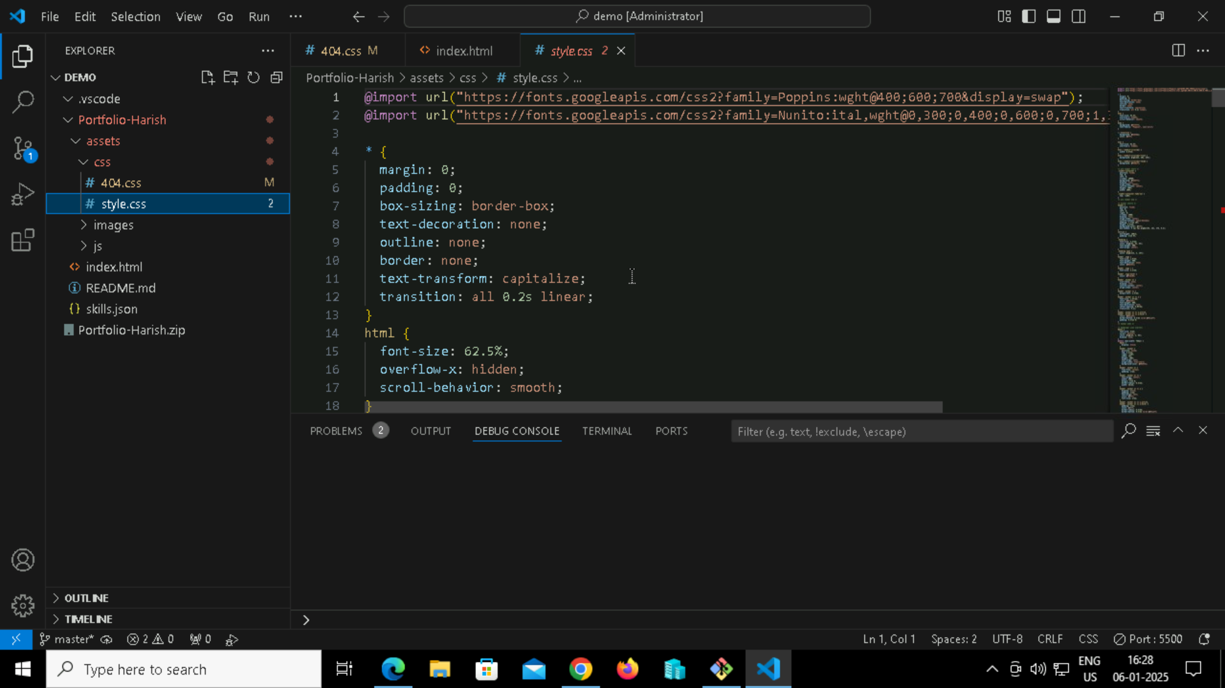

@import url("https://fonts.googleapis.com/css2?family=Poppins:wght@400;600;700&display=swap");

@import url("https://fonts.googleapis.com/css2?family=Nunito:ital,wght@0,300;0,400;0,600;0,700;1,300;1,400&display=swap");

* {

*margin*: 0;

*padding*: 0;

*box-sizing*: border-box;

*text-decoration*: none;

*outline*: none;

*border*: none;

*text-transform*: capitalize;

*transition*: all 0.2s linear;

}html {

*font-size*: 62.5%;

*overflow-x*: hidden;

*scroll-behavior*: smooth;

}body {

*background*: #f7f7f7;

*font-family*: "Poppins", sans-serif;

}

*::selection {

*background*: #2b3dda;

*color*: #fff;

}html {

*font-size*: 62.5%;

*overflow-x*: hidden;

}html::-webkit-scrollbar {

*width*: 0.8rem;

}html::-webkit-scrollbar-track {

*background*: rgb(235, 202, 245);

}html::-webkit-scrollbar-thumb {

*background*: #420177;

}

/* pre loader start */

.loader-container {

*position*: fixed;

*top*: 0;

*left*: 0;

*z-index*: 10000;

*background*: #e6eff1;

*display*: flex;

*align-items*: center;

*justify-content*: center;

*height*: 100%;

*width*: 100%;

}.loader-container.fade-out {

*top*: -120%;

}/* pre loader end */

/* navbar starts */

header {

*position*: fixed;

*top*: 0;

*left*: 0;

*right*: 0;

*z-index*: 1000;

*display*: flex;

*align-items*: center;

*justify-content*: space-between;

*padding*: 1.7rem 10%;

*height*: 6.5rem;

*background-color*: #fff;

*box-shadow*: 0 1px 4px rgba(146, 161, 176, 0.3);

}section {

*min-height*: 100vh;

*padding*: 2rem 9%;

}.heading {

*font-size*: 3.5rem;

*color*: rgb(32, 32, 32);

*font-weight*: 800;

*text-align*: center;

}.heading span {

*color*: rgb(115, 3, 167);

}header .logo {

*font-size*: 1.9rem;

*font-weight*: 800;

*text-decoration*: none;

*color*: #0e2431;

}header .logo i {

*font-size*: 2.2rem;

}header .logo:hover {

*color*: #fc8c05;

}header .navbar ul {

*list-style*: none;

*display*: flex;

*justify-content*: center;

*align-items*: center;

}header .navbar li {

*margin-left*: 2.5rem;

}header .navbar ul li a {

*font-size*: 1.57rem;

*color*: #0e2431;

*font-weight*: 600;

*text-decoration*: none;

*letter-spacing*: 0.04rem;

*transition*: 0.2s;

}header .navbar ul li a.active,

header .navbar ul li a:hover {

*color*: #011aff;

*border-bottom*: 0.2rem solid #011aff;

*padding*: 0.5rem 0;

}/* navbar ends */

/* hamburger icon starts*/

#menu {

*font-size*: 3rem;

*cursor*: pointer;

*color*: rgb(24, 2, 63);

*display*: none;

}@media (*max-width*: 768px) {

  #menu {

*display*: block;

  }  header .navbar {

*position*: fixed;

*top*: 6.5rem;

*right*: -120%;

*width*: 75%;

*height*: 100%;

*text-align*: left;

*align-items*: flex-start;

*background-color*: #0e0f31;

  }  header .navbar ul {

*flex-flow*: column;

*padding*: 1rem;

  }  header .navbar ul li {

*text-align*: center;

*width*: 100%;

*margin*: 1rem 0;

*border-radius*: 0.5rem;

*width*: 26rem;

  }  header .navbar ul li a {

*display*: block;

*padding*: 1rem;

*text-align*: left;

*color*: #fff;

*font-size*: 2rem;

  }  header .navbar ul li a.active,

  header .navbar ul li a:hover {

*padding*: 1rem;

*color*: #fff;

*border-radius*: 0.5rem;

*border-bottom*: 0.5rem solid #011aff;

  }  .fa-times {

*transform*: rotate(180deg);

  }  header .navbar.nav-toggle {

*right*: 0;

  }}/* hamburger icon ends */

/* hero section starts*/